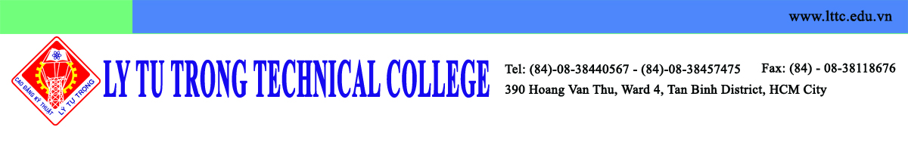
Dear Dr. Seman PYO, Director of Institute of IALE,

On behalf of Ly Tu Trong Technical College Ho Chi Minh City, I would like to say thank you for your help. It is my great honor to be welcomed at Kunsan National University in December. I hereby inform you the delegation list so that it could be more convenient for your arrangement:

1. Mr. Pham Ngoc Thanh, Vice Director of Department of Education and Training of Ho Chi Minh City
2. Mr. Pham Huu Loc, Rector of Ly Tu Trong Technical College Ho Chi Minh City
3. Ms. Nguyen Ngoc Trang, Dean of Scientific Management and International Cooperation Office – Ly Tu Trong Technical College Ho Chi Minh City
4. Mr. Do Cong Thanh, Official of Ly Tu Trong Training Center
5. Mr. Nguyen Phu Thuong Luu, Lecturer

I am looking forward to continuing to cooperate with you to make valuable contributions to the technical education in both schools and the students could get great benefit from this cooperation.

Best regards,

Pham Huu Loc
Rector
Ly Tu Trong Technical College Ho Chi Minh City

